**Aim**: Create Dashboard and Storytelling using tableau

**Theory:**

Well, it is a sequence of different charts that combine to provide a cohesive plot to its viewers. In essence, all these charts tell a story about the data which allows the viewers to form their conclusion. The story in Tableau contains story points, where each story point is either a worksheet or a dashboard.

Steps:

**Step 1:** Click on the new Story tab to create a new story. You can then add various sheets and dashboards to create a story point.

**Step 2:** You can double-click on the sheets and dashboards on the left to add them to a story point. You can also drag the sheets into your story point on the Tableau desktop. All the sheets and dashboards that are added to a story are connected to their original forms. So any changes made to the original sheets or dashboards are reflected in the story. For example, let’s add a dashboard containing the relation between Discounted Sales and Profit by Category to the story.

**Step 3:** We can also add a caption to summarize the story point by clicking on “Add a caption” and then writing it. Let’s add the caption “Relation between Discounted Sales and Profit by Category and Subcategory” to our example.

**Step 4:** It is possible to add another story point by 2 methods. You can either click on the Blank tab to use a blank sheet for the next story point or click on the Duplicate tab to obtain a duplicate sheet as the current story point. Let’s click on the blank option. Dataset use here is **Superstore** Dataset.

**Output:**

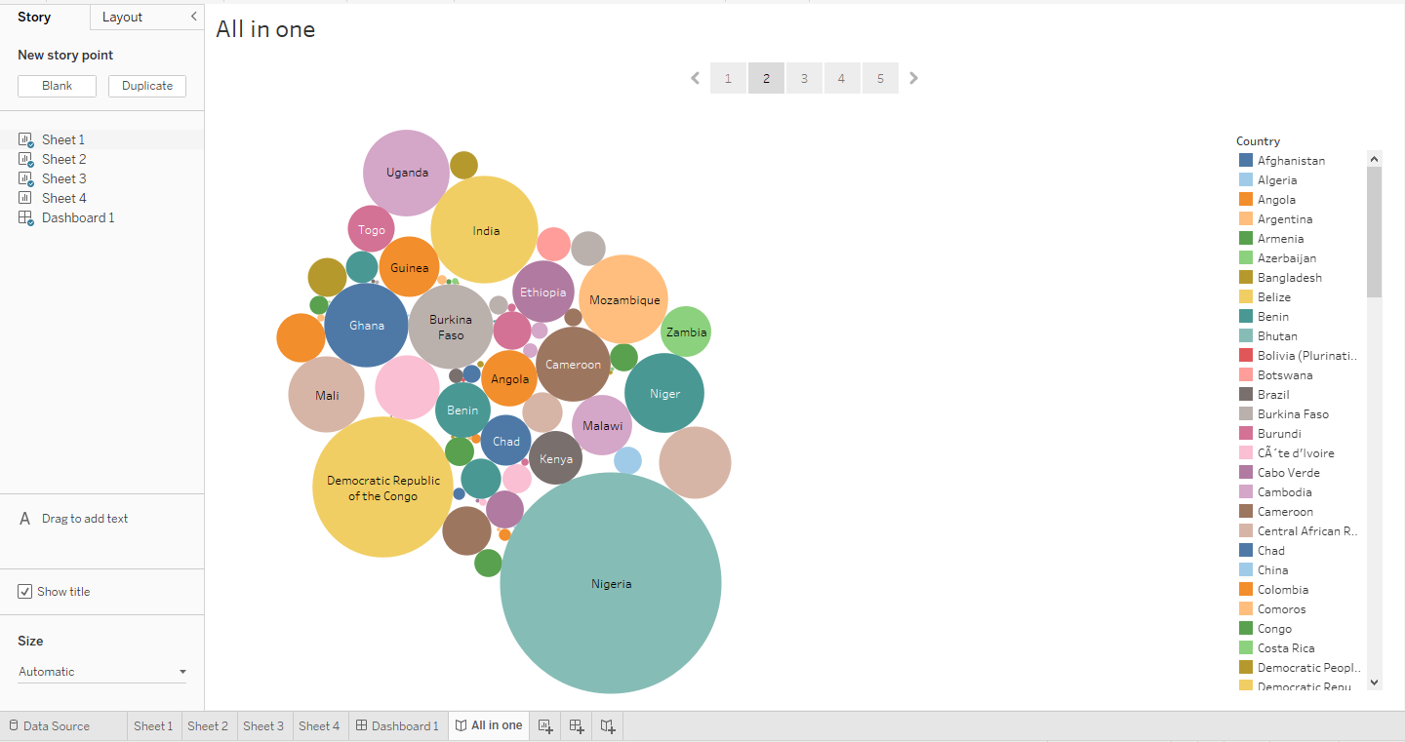

**Result:**

Here we saw how to create the story board of the data by dragging and dropping the sheet in the story board area.